Steven Kim

Mr. Mason

ADV Cisco CCNP P 1, 2

3/3/14

Partner: Hoi Leung

Lab 8: First Hop Redundancy - VRRP, HSRP, and GLBP

**Purpose**

The purpose of this lab is to set up three first hop redundancy protocols that assign addresses to virtual routers in case the physical router fails. These protocols are essentially “backup protocols” in case the network loses connectivity with the default gateway.

**Background Information on lab concepts**

Virtual Router Redundancy Protocol (VRRP): A protocol that automatically assigns IP addresses to virtual routers as backups for failures of the physical router. Unlike HSRP and GLBP, this protocol increases the availability and reliability of various router paths. In addition, this protocol creates virtual routers that represent different routers on a network. When this protocol is implemented the default gateway is assigned to a virtual router IP address instead of a physical one; therefore, if this virtual interface fails, another physical or virtual router is selected to replace the one that failed. To summarize, VRRP is simply a protocol that creates backups for the physical router.

Hot Standby Router Protocol (HSRP): A Cisco proprietary redundancy protocol that not only converges quickly with other routing protocols like EIGRP and OSPF but also serves to overcome default gateway failures. Unlike VRRP and GLBP, HSRP is not a routing protocol, for it does not impact the routing table. It also uses multicast packets to set priorities and allows the router with the highest priority to act as the primary virtual router that can respond to ARP requests. If the virtual router with the highest priority fails, the virtual router with the second highest priority takes over the function of its precedent. The default local multicast address for HSRP version 1 is 224.0.0.2, 224.0.0.102 for version 2.

Gateway Load Balancing Protocol (GLBP): A Cisco proprietary protocol that adds a loading balancing feature in order to overcome the difficulties of previous redundant router protocol. This protocol establishes a weighting parameter that organizes how ARP requests will be answered. It also elects an Active Virtual Gateway (AVG) per GLBP group. Typically, there are three types of virtual states that a group can be in: the Standby state for the second best AVG and the Listening state for the rest of the groups. A virtual MAC address is assigned to each member of the GLBP group. The default local multicast address for GLBP routers is 224.0.0.102.

NOTE: The default priority for all three protocols is 100. This is one of the reasons why I chose to put priority numbers higher than 100 in my configurations section.

**Lab Summary**

VRRP

1. Connect the host and the two routers to the switch. One router will act as the primary default gateway, and the other as backup.
2. Issue the command *vrrp [group-number] ip [virtual ip address]* on both routers. Make sure that the group number and the virtual IP address are the same for both routers.
3. Set a priority on the interface by issuing the command *vrrp [group-number] preempt* and then *vrrp [group-number] priority.* This former will allow preemption, and the latter will set a priority. Remember that if preemption has been enabled while the main default gateway (primary router) fails, the router with the highest priority will become the main primary default gateway. For testing priority, I configured priorities higher than 100 (default) on both routers.
4. Make sure that the end devices have established connectivity by opening command prompt and request a continuous ping. Pull one of the straight-through cables that connect a router to a switch. The ping request will fail for a couple packets but will soon be established.
5. When connectivity is fully established, it is safe to assume that VRRP is working properly.

HSRP

Repeat steps 1-5 of VRRP, but instead of typing *vrrp* in front of *[group-number] ip [virtual ip*

*address],* type *standby.*

GLBP

Repeat steps 1-5 of VRRP, but instead of typing *vrrp* in front of *[group-number] ip [virtual ip*

*address],* type *glbp.*

**Lab Commands**

Command for VRRP

|  |  |
| --- | --- |
| Router (config-if)# *vrrp [group-number] ip [virtual ip address]* | Enables VRRP by assigning a secondary IP address to the virtual router. |
| Router (config-if)# *vrrp [group-number] preempt* | Enables preemption on the router. |
| Router (config-if)# *vrrp [group-number] priority* | Sets a priority on the interface. |

Command for HSRP

|  |  |
| --- | --- |
| Router (config-if)# *standby [group-number] ip [virtual ip address]* | Enables HSRP by assigning a secondary IP address to the virtual router. |
| Router (config-if)# *standby [group-number] preempt* | Enables preemption on the router. |
| Router (config-if)# *standby [group-number] priority* | Sets a priority on the interface. |

Command for GLBP

|  |  |
| --- | --- |
| Router (config-if)# *glbp [group-number] ip [virtual ip address]* | Enables GLBP by assigning a secondary IP address to the virtual router. |
| Router (config-if)# *glbp [group-number] preempt* | Enables preemption on the router. |
| Router (config-if)# *glbp [group-number] priority* | Sets a priority on the interface. |

**Network Diagram with IP’s**

For all three routing protocols, the following diagram was used:

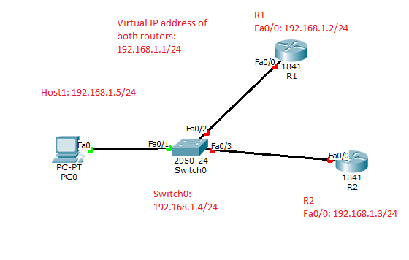

**Configurations**

VRRP

Show run on R1

R1#sh run

Building configuration...

Current configuration : 1472 bytes

!

version 15.1

service timestamps debug datetime msec

service timestamps log datetime msec

no service password-encryption

!

hostname R1

!

boot-start-marker

boot-end-marker

!

no aaa new-model

memory-size iomem 10

!

no ipv6 cef

ip source-route

ip cef

!

!

!

!

!

no ip domain lookup

multilink bundle-name authenticated

!

!

crypto pki token default removal timeout 0

!

interface GigabitEthernet0/0

ip address 192.168.1.2 255.255.255.0

duplex auto

speed auto

vrrp 1 ip 192.168.1.1

vrrp 1 priority 102

!

line con 0

password cisco

login

line aux 0

line vty 0 4

password cisco

login

transport input all

!

scheduler allocate 20000 1000

end

Show run on R2

R2#sh run

Building configuration...

Current configuration : 941 bytes

!

! Last configuration change at 16:16:28 UTC Thu Feb 27 2014

!

version 15.0

service timestamps debug datetime msec

service timestamps log datetime msec

no service password-encryption

!

hostname R2

!

boot-start-marker

boot-end-marker

!

!

no aaa new-model

memory-size iomem 10

!

ip source-route

!

!

ip cef

!

!

no ip domain lookup

multilink bundle-name authenticated

!

!

!

license udi pid CISCO2811 sn FTX1508AJ0X

!

!

!

!

!

!

interface FastEthernet0/0

ip address 192.168.1.3 255.255.255.0

duplex auto

speed auto

vrrp 1 ip 192.168.1.1

vrrp 1 priority 101

!

!

line con 0

line aux 0

line vty 0 4

no login

!

scheduler allocate 20000 1000

end

HSRP

Show run on R1

R1#sh run

Building configuration...

Current configuration : 1205 bytes

!

! Last configuration change at 16:24:07 UTC Thu Feb 27 2014

version 15.2

service timestamps debug datetime msec

service timestamps log datetime msec

no service password-encryption

!

hostname R1

!

boot-start-marker

boot-end-marker

!

!

!

!

!

interface Embedded-Service-Engine0/0

no ip address

shutdown

!

interface GigabitEthernet0/0

ip address 192.168.1.2 255.255.255.0

standby 1 ip 192.168.1.1

standby 1 priority 102

standby 1 preempt

duplex auto

speed auto

!

ip forward-protocol nd

!

no ip http server

no ip http secure-server

!

!

!

!

!

control-plane

!

!

!

line con 0

line aux 0

line vty 0 4

login

transport input all

!

scheduler allocate 20000 1000

!

end

Show run on R2

R2#sh run

Building configuration...

Current configuration : 1343 bytes

!

! Last configuration change at 16:33:41 UTC Thu Feb 27 2014

version 15.2

service timestamps debug datetime msec

service timestamps log datetime msec

no service password-encryption

!

hostname R2

!

interface Embedded-Service-Engine0/0

no ip address

shutdown

!

interface GigabitEthernet0/0

ip address 192.168.1.3 255.255.255.0

standby 1 ip 192.168.1.1

standby 1 priority 101

standby 1 preempt

duplex auto

speed auto

!

line con 0

line aux 0

line vty 0 4

login

transport input all

!

scheduler allocate 20000 1000

!

end

GLBP

Show run on R1

R1#sh run

Current configuration : 1183 bytes

!

version 12.4

service timestamps debug datetime msec

service timestamps log datetime msec

no service password-encryption

!

hostname R1

!

boot-start-marker

boot-end-marker

!

!

!

!

!

interface FastEthernet0/0

ip address 192.168.1.2 255.255.255.0

duplex auto

speed auto

glbp 1 ip 192.168.1.1

glbp 1 priority 102

glbp 1 preempt

!

!

!

ip forward-protocol nd

no ip http server

no ip http secure-server

!

!

!

!

!

line con 0

line aux 0

line vty 0 4

login

!

scheduler allocate 20000 1000

end

Show run on R2

R2#sh run

Current configuration : 1564 bytes

!

version 12.4

service timestamps debug datetime msec

service timestamps log datetime msec

no service password-encryption

!

hostname R2

!

boot-start-marker

boot-end-marker

!

logging message-counter syslog

!

no aaa new-model

memory-size iomem 10

no network-clock-participate slot 1

!

!

!

!

!

!

interface FastEthernet0/0

ip address 192.168.1.3 255.255.255.0

duplex auto

speed auto

glbp 1 ip 192.168.1.1

glbp 1 priority 101

glbp 1 preempt

!

!

interface Vlan1

no ip address

!

ip forward-protocol nd

no ip http server

no ip http secure-server

!

!

line con 0

line aux 0

line vty 0 4

login

!

scheduler allocate 20000 1000

end

Show vrrp

R1#sh vrrp

GigabitEthernet0/0 - Group 1

State is Master

Virtual IP address is 192.168.1.1

Virtual MAC address is 0000.5e00.0101

Advertisement interval is 1.000 sec

Preemption enabled

Priority is 102

Master Router is 192.168.1.2 (local), priority is 102

Master Advertisement interval is 1.000 sec

Master Down interval is 3.601 sec

R2#show vrrp

GigabitEthernet0/0 - Group 1

State is Master

Virtual IP address is 192.168.1.1

Virtual MAC address is 0000.5e00.0101

Advertisement interval is 1.000 sec

Preemption enabled

Priority is 101

Master Router is 192.168.1.3 (local), priority is 101

Master Advertisement interval is 1.000 sec

Master Down interval is 3.605 sec

Show standby

R1#show standby

GigabitEthernet0/0 - Group 1

State is Speak

3 state changes, last state change 00:01:37

Virtual IP address is 192.168.1.1

Active virtual MAC address is unknown

Local virtual MAC address is 0000.0c07.ac01 (v1 default)

Hello time 3 sec, hold time 10 sec

Next hello sent in 1.904 secs

Preemption enabled

Active router is unknown

Standby router is unknown

Priority 102 (configured 102)

Group name is "hsrp-Gi0/0-1" (default)

R2#show standby

FastEthernet0/0 - Group 1

State is Active

5 state changes, last state change 00:00:18

Virtual IP address is 192.168.1.1

Active virtual MAC address is 0000.0c07.ac01

Local virtual MAC address is 0000.0c07.ac01 (v1 default)

Hello time 3 sec, hold time 10 sec

Next hello sent in 2.768 secs

Preemption enabled

Active router is local

Standby router is unknown

Priority 101 (configured 101)

Group name is "hsrp-Fa0/0-1" (default)

Show glbp

R1#sh glbp

FastEthernet0/0 - Group 1

State is Active

1 state change, last state change 00:01:57

Virtual IP address is 192.168.1.1

Hello time 3 sec, hold time 10 sec

Next hello sent in 0.416 secs

Redirect time 600 sec, forwarder timeout 14400 sec

Preemption enabled, min delay 0 sec

Active is local

Standby is 192.168.1.3, priority 101 (expires in 9.504 sec)

Priority 102 (configured)

Weighting 100 (default 100), thresholds: lower 1, upper 100

Load balancing: round-robin

Group members:

0012.d974.b568 (192.168.1.3)

0022.900c.dd08 (192.168.1.2) local

There are 2 forwarders (1 active)

Forwarder 1

State is Active

1 state change, last state change 00:01:46

MAC address is 0007.b400.0101 (default)

Owner ID is 0022.900c.dd08

Redirection enabled

Preemption enabled, min delay 30 sec

Active is local, weighting 100

Client selection count: 4

Forwarder 2

State is Listen

MAC address is 0007.b400.0102 (learnt)

Owner ID is 0012.d974.b568

Redirection enabled, 597.408 sec remaining (maximum 600 sec)

Time to live: 14397.408 sec (maximum 14400 sec)

Preemption enabled, min delay 30 sec

Active is 192.168.1.3 (primary), weighting 100 (expires in 8.672 sec)

R2#sh glbp

FastEthernet0/0 - Group 1

State is Speak

Virtual IP address is 192.168.1.1

Hello time 3 sec, hold time 10 sec

Next hello sent in 2.688 secs

Redirect time 600 sec, forwarder timeout 14400 sec

Preemption enabled, min delay 0 sec

Active is unknown

Standby is unknown

Priority 101 (configured)

Weighting 100 (default 100), thresholds: lower 1, upper 100

Load balancing: round-robin

Group members:

0012.d974.b568 (192.168.1.3) local

There are no forwarders

Pings  
**VRRP**

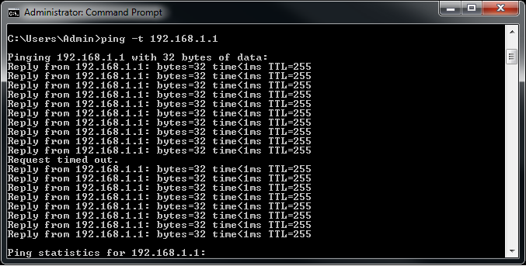  
The *Request timed out* that shows that connection is quickly restored after the cable is unplugged.  
**HSRP**  
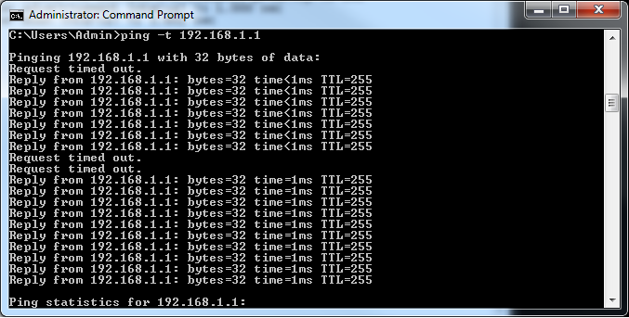

The *Request timed out* that shows that connection is quickly restored after the cable is unplugged.

**GLBP**

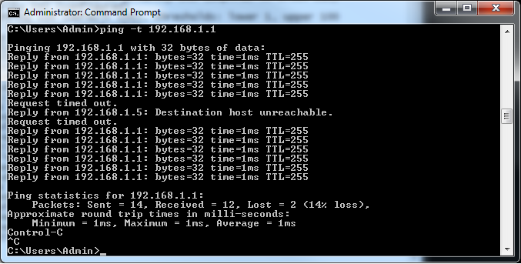

The *Request timed out* and *Reply from 192.1268.1.5: Destination host unreachable* above shows that it takes some time to restore connection.

**Problem**

Since the process and the configurations were relatively simple, I had very few problems in this lab. The most dominant problem that I had, however, was initial insufficient research. I did not realize that the commands *vrrp [group-number] preempt* and *vrrp [group-number] priority* were necessary: I thought they were optional commands that were not a major part of this lab. However, as I discovered that connectivity was not restored when the primary router failed, I had to go back and issue these two commands.  
 Also, I did not put the same virtual IP address for both routers. This also prevented the protocol from working because the router recognized two separate default gateways. After I had undergone some trouble shooting, I discovered that the same virtual IP address was necessary.

**Conclusion**

Overall, I managed to implement three different router protocols in networks: HSRP, VRRP, and GLBP. Although my initial inadequate research impeded me, I eventually managed to successfully implement these three protocols. I learned how to set up backup routers in the network without having to lose complete connection between a host and a router.